# **Appendix - Setting up the Payload SD Card**

***Note: Only perform the steps in this guide if your Raspberry Pi SD Card does not boot up normally.***

This User Guide presents the steps to reset your SD Card if it is unable to boot up.

**Table of Contents**

Appendix - Setting up the Payload SD Card 1

Items required 1

Step 1: Flashing the Raspbian OS to SD card 2

Step 2: Copy Custom Setup scripts to the SD Card 8

Step 3: Configure WiFi credentials to the Raspberry Pi OS 10

Step 4: Enable SSH in the Raspberry Pi OS 11

Step 5: Boot up Raspberry Pi 11

Step 6: SSH into Raspberry Pi 12

Step 7: Run Custom Setup scripts in Raspberry Pi 14

Step 8: View GUI of the Raspberry Pi 16

Step 9: Configure the GUI settings 18

# **Items required**

Here is a list of items required for the mass production of SD Card.

|  |  |
| --- | --- |
| **Items** | **Remarks** |
| Raspberry Pi 3B+ |  |
| SanDisk 32 GB Ultra Micro SD Card |  |
| SD Card Reader | Optional, depends on PC type so that  Micro SD Card may be inserted into PC |
| Raspberry Pi Micro-USB Power Supply |  |
| Monitor |  |
| HDMI Cable | HDMI on one side, and the other side  depends on the input required by the Monitor used |
| USB Keyboard | Can be wired or wireless |
| USB Mouse | Can be wired or wireless |

Setup and operations were tested on a PC that runs on Windows 10.

## **Step 1: Flashing the Raspbian OS to SD card**

1. Download and install the Raspberry Pi Imager application from the website [here](https://www.raspberrypi.org/software/).

Website: <https://www.raspberrypi.org/software/>

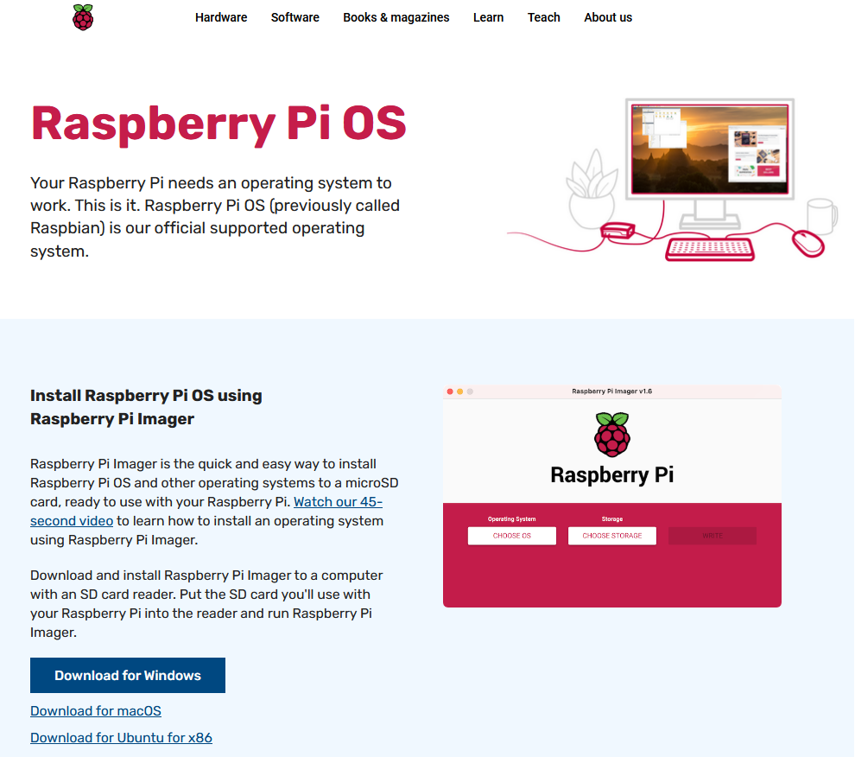

1. Launch the Raspberry Pi Imager application.

The Imager application should look like this:

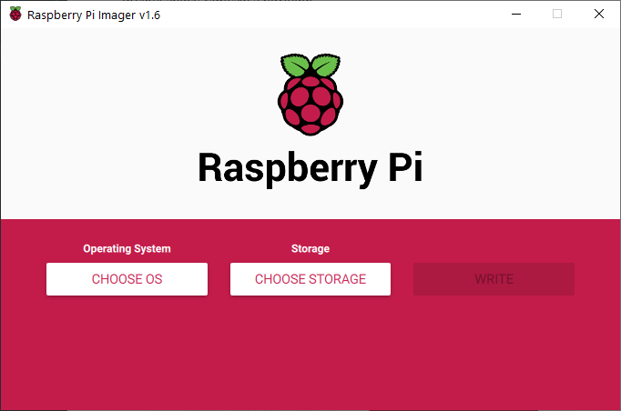

1. Click on the Choose OS button under the Operating System section.

The Choose OS button is boxed in **green** in the image below.

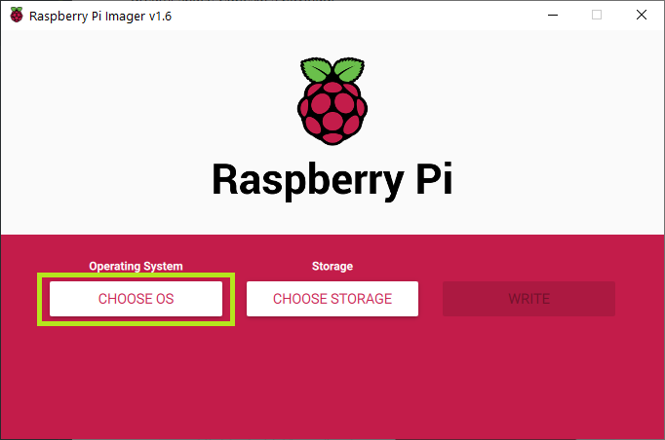

1. Select the first option, Raspberry Pi OS (32-bit).

The first option Raspberry Pi OS (32-bit) is boxed in **green** in the image below.

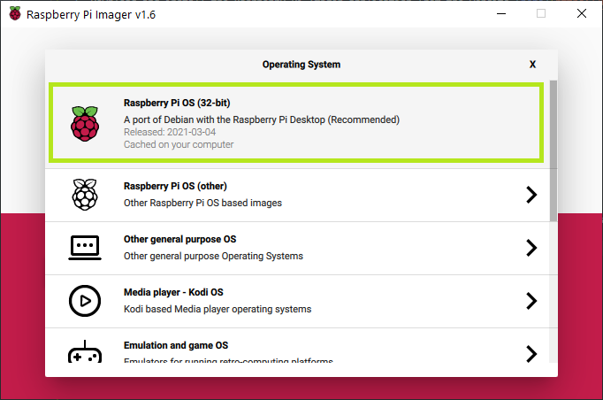

1. Click on the Choose Storage button under the Storage section.

The Choose Storage button is boxed in **green** in the image below.

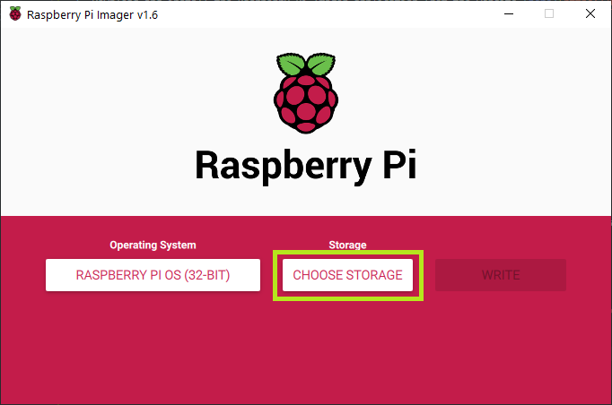

1. Click on the SD Card storage to flash the OS onto.

|  |  | **⚠️** | **To prevent overwriting your other drives, it is recommended to eject all drives before inserting the SD Card.** |
| --- | --- | --- | --- |
|  |  |  |  |

1. For example, the SD Card detected is shown and boxed in **green** in the image below.

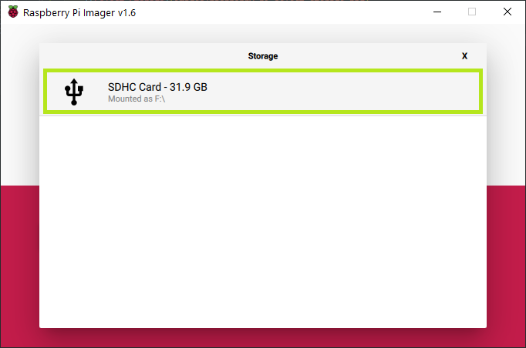

1. Click on the Write button to begin the flashing.

The Write button is boxed in **green** in the image below.

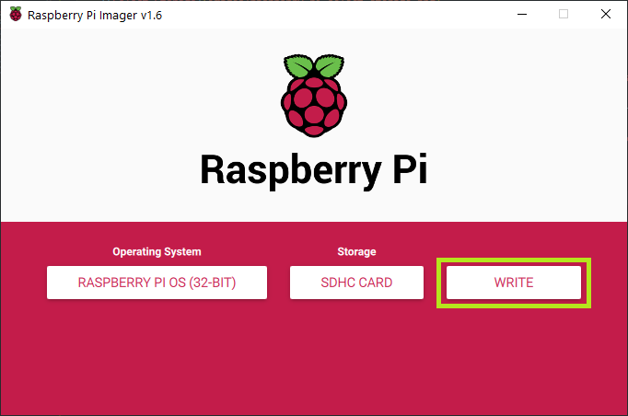

Click Yes to overwrite the SD Card.

The Yes button is boxed in **green** in the image below.

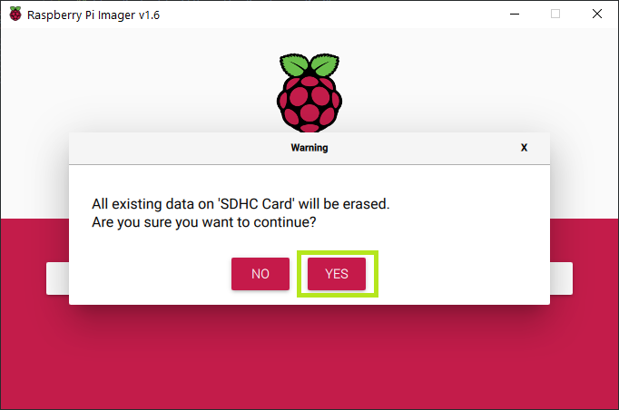

1. Wait for the OS write process to complete.

Upon completion, click the Continue button boxed in **green** in the image below.

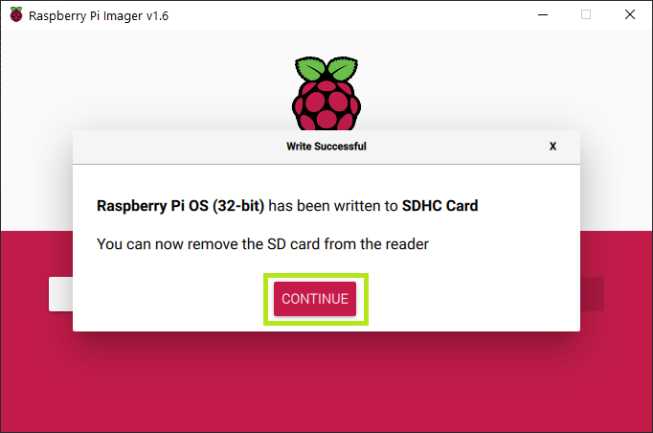

1. Eject the SD Card and re-insert the SD Card into the PC again.

Open the File Explorer and go to This PC.

A boot drive should appear after re-inserting the SD Card.

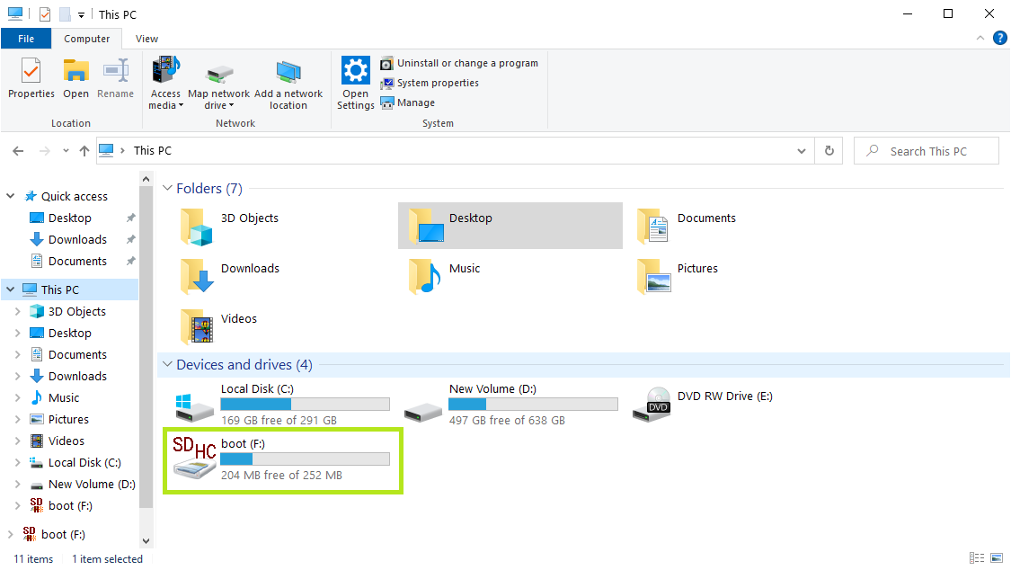

## **Step 2: Copy Custom Setup scripts to the SD Card**

1. Click on the boot drive in File Explorer.

| **⚠️** | **Do not open or make changes to any files in this drive, unless you are 100% sure.** |
| --- | --- |

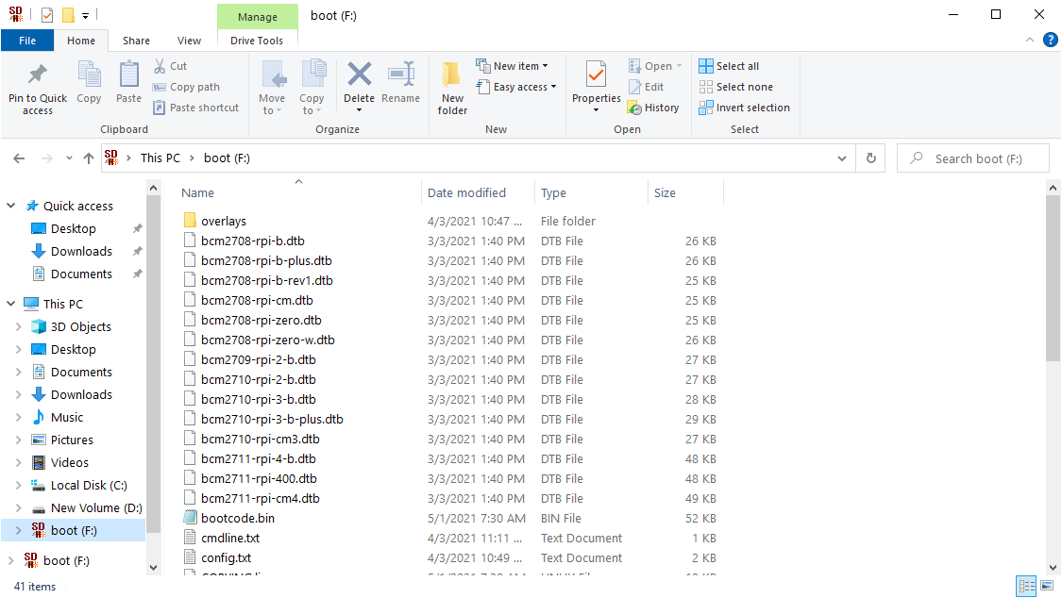

1. Download and copy the config scripts into the boot drive.

|  | **⚠️** | **Do not edit any part of the files, except for those steps in the instructions.** |  |
| --- | --- | --- | --- |

1. The config scripts can be downloaded from here:
   * [payload_config.sh](https://dream2space.github.io/dream2space-wiki/payload_config.sh)
   * [system_setup.sh](https://dream2space.github.io/dream2space-wiki/system_setup.sh)
   * [wpa_supplicant.conf](https://dream2space.github.io/dream2space-wiki/wpa_supplicant.conf)

Once the copying is complete, the 3 files should appear like in the image below.

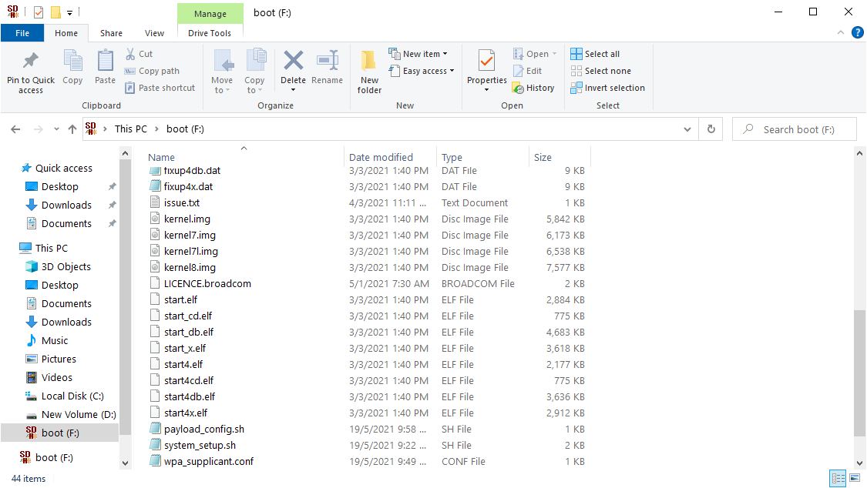

## **Step 3: Configure WiFi credentials to the Raspberry Pi OS**

1. Locate the wpa_supplicant.conf file in the boot drive and open it using Notepad.

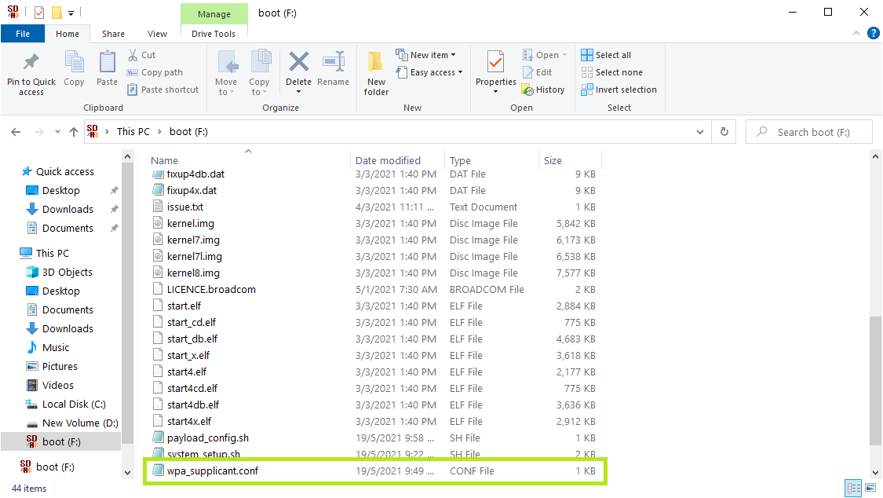

1. Fill in the template with the WiFi Router name and the Password.

Save the changes in the file.

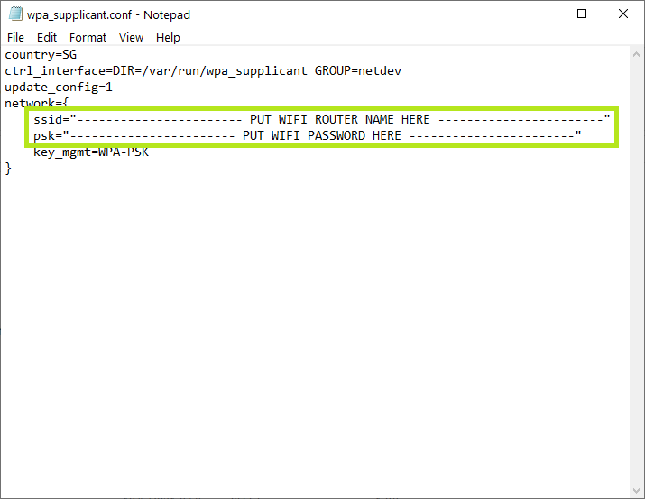

## **Step 4: Enable SSH in the Raspberry Pi OS**

1. Download an empty ssh file from the link [here](https://dream2space.github.io/dream2space-wiki/ssh).
2. Copy the file into the boot drive.

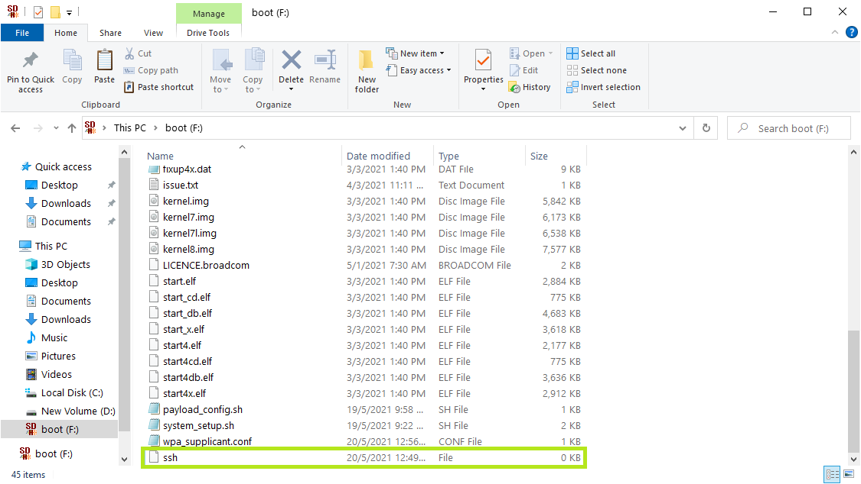

## **Step 5: Boot up Raspberry Pi**

Power up the Raspberry Pi.

## **Step 6: SSH into Raspberry Pi**

1. Ensure that PuTTY is installed on the PC.

You may download PuTTY from this website [here](https://www.chiark.greenend.org.uk/~sgtatham/putty/latest.html)

Website: <https://www.chiark.greenend.org.uk/~sgtatham/putty/latest.html/>

1. Open up PuTTY and SSH into PuTTY.

To SSH into PuTTY, enter raspberrypi.local into the Host Name (or IP address) box boxed in **green** in the image below.

Ensure that the Port entered is 22 (by default).

Click Open, which is boxed in **blue** in the image.

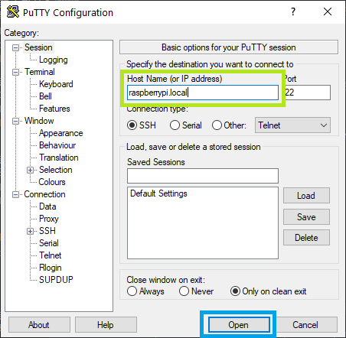

1. Login to the Raspberry Pi when prompted.

The default credentials for Raspberry Pi login are here:

* + username: pi
  + password: raspberry

After entering the username and password individually (and sequentially), press Enter to confirm.

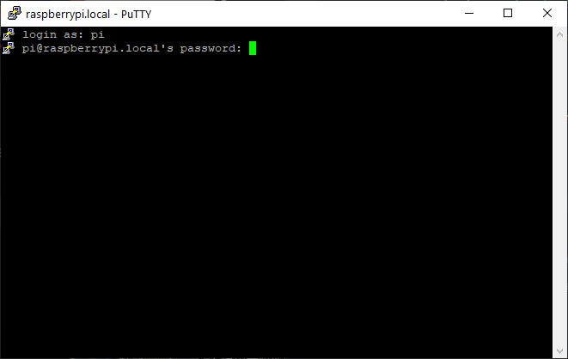

If the login is successful, the screen below will appear.

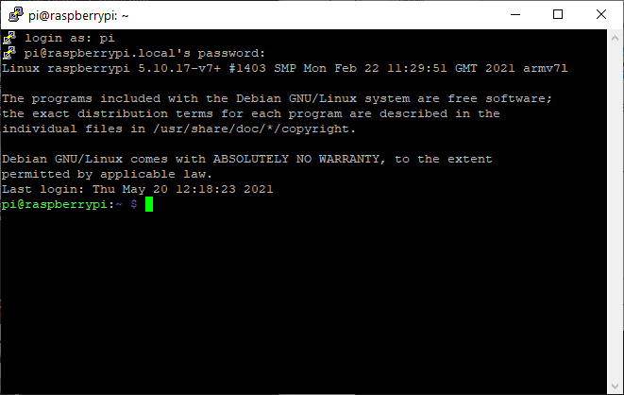

## **Step 7: Run Custom Setup scripts in Raspberry Pi**

1. Run the payload_config.sh script that is saved in the boot drive to install the libraries and Payload Manager code.

To do so, type the following command into the PuTTY terminal and press Enter:

sudo /boot/payload_config.sh

The payload_config.sh script will run and wait till its completion.

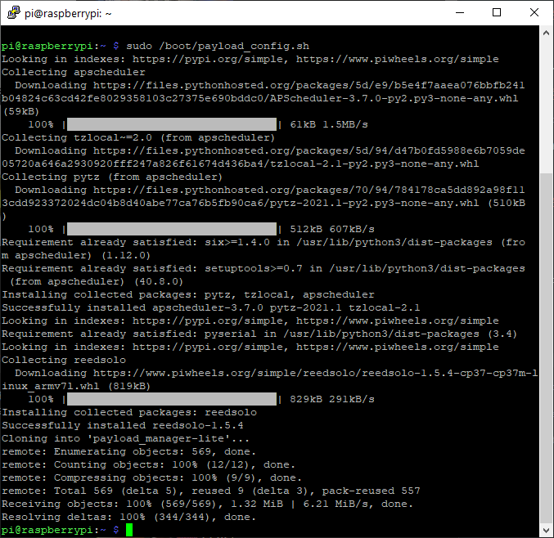

1. Run the system_setup.sh script that is saved in the boot drive to setup the Raspberry Pi.

To do so, type the following command into the PuTTY terminal and press Enter.

sudo /boot/system_setup.sh

The system_setup.sh script will run and wait till its completion.

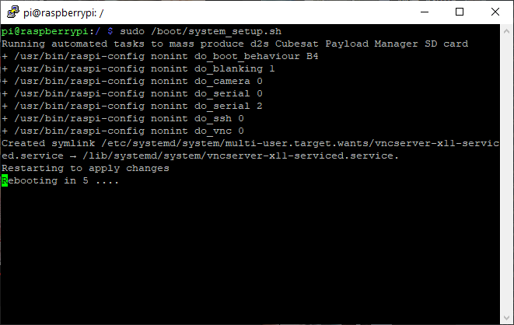

Upon its completion, the Raspberry Pi will reboot and the PuTTY terminal connection will be disconnected.

Close the PuTTY terminal.

## **Step 8: View GUI of the Raspberry Pi**

1. Plug in a HDMI cable to the Raspberry Pi and connect the HDMI cable to a Monitor.

The HDMI port is boxed in **red** in the image below.

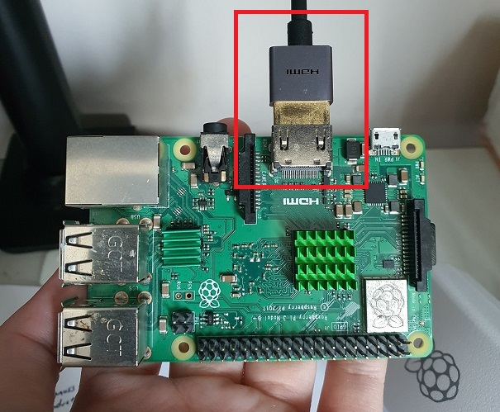

Connect the USB keyboard and USB mouse to the Raspberry Pi's USB ports.

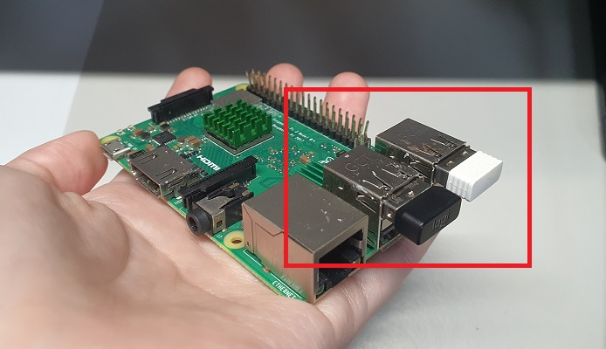

1. Switch to the HDMI source to view the Raspberry Pi GUI.

Upon successful viewing of the GUI, the following screen will show:

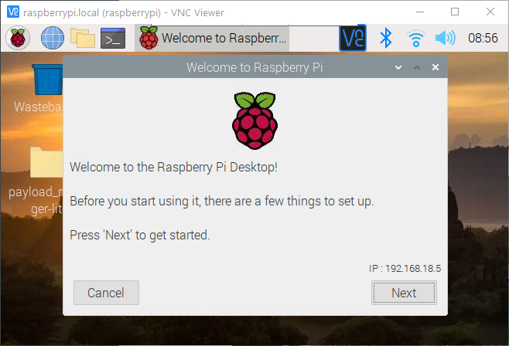

## **Step 9: Configure the GUI settings**

The GUI settings of the Raspberry Pi will be configured.

| **⚠️** | **Make sure that all the steps here are completed before powering off the Raspberry Pi.** |
| --- | --- |

1. Click on the Next button to proceed with the setup.

The Next button is boxed in **green** in the image below.

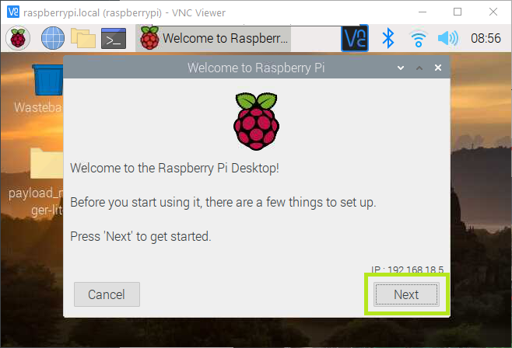

1. Select the Country, Language and Timezone.
   * Country: Singapore
   * Language: English
   * Timezone: Singapore

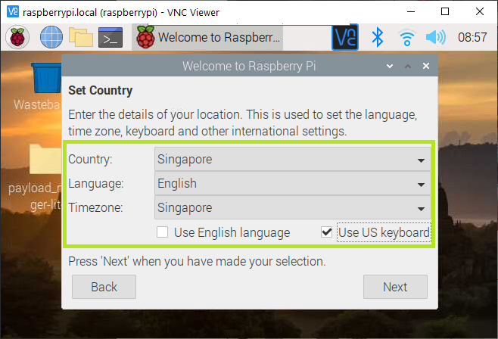

Click the Next button to proceed.

1. Configure the password for the Raspberry Pi OS.

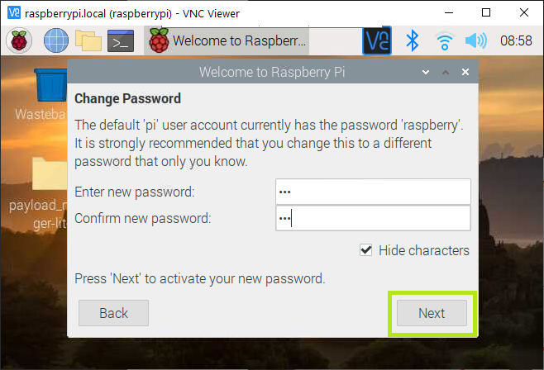

Click the Next button to proceed.

1. Click the Next button to skip setting the Screen configurations.

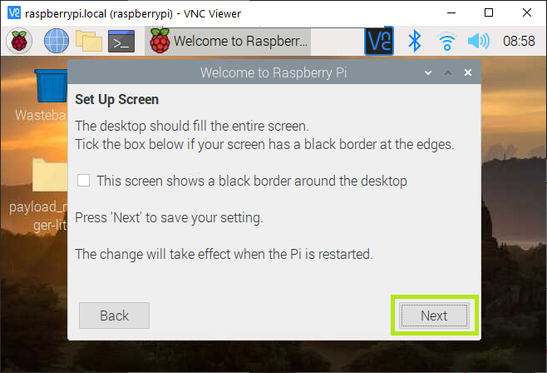

1. Click the Skip button to skip configuring the WiFi.

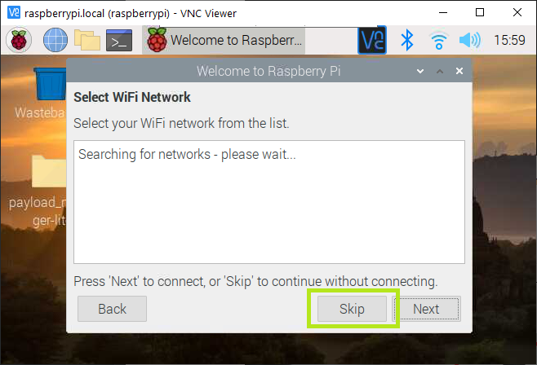

1. Click the Skip button to skip updating the OS.

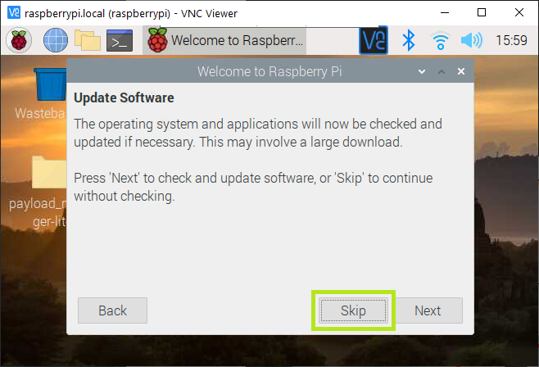

1. Click Done to complete setup.

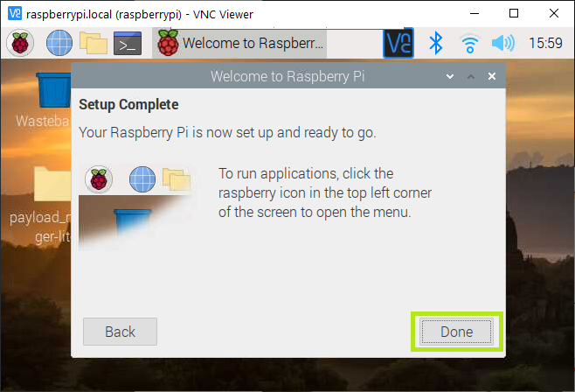

1. Shutdown the Raspberry Pi.

To navigate to the Shutdown menu, click on the Raspberry Pi Logo at the top left-hand corner and click the Logout button.

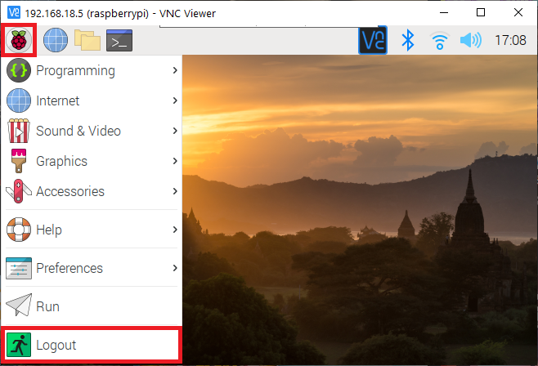

Select Shutdown to shut down the Raspberry Pi safely.

